BUCKETWISE DATA SEGMENTATION OVER THE ZONES:

**SOURCE:** We have taken this bucket as the receiving end from client, it is being treated as a foreign bucket so we crawl the data and then put the data into the landing bucket.

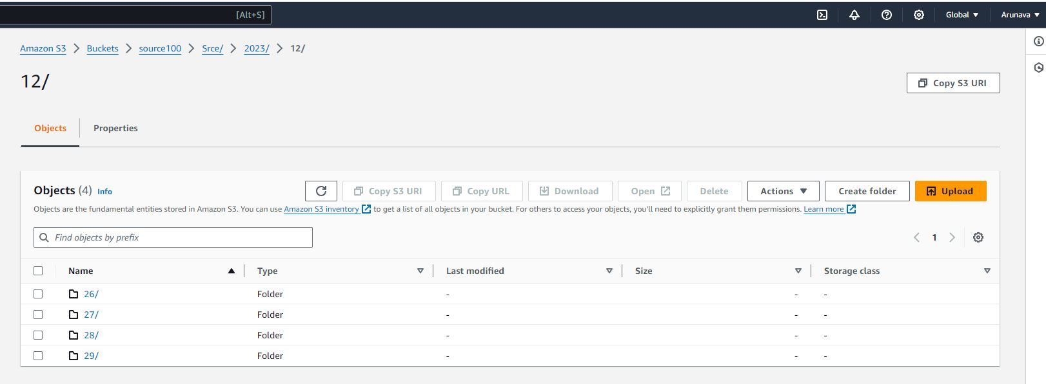

**LANDING:** So here we are placing the data after crawling, at this stage we are forming data cataloging

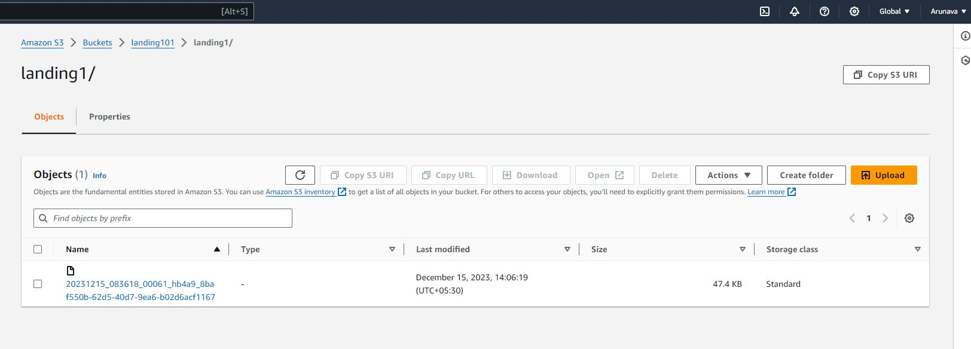

**RAW:** At this stage we are assigning the primary key and set the ingest-dt and source ts-ms then unload that into the raw zone bucket.

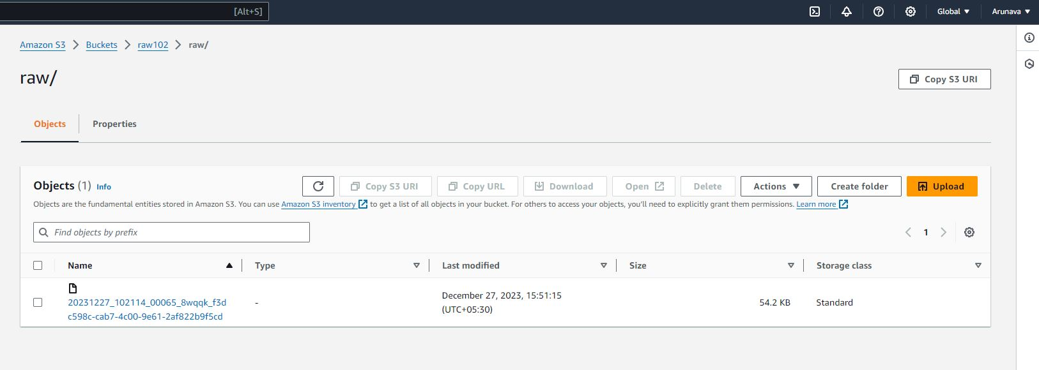

**STANDARDIZATION:** At this zone we are performing hudi-upsert, we are removing duplicity at this layer.

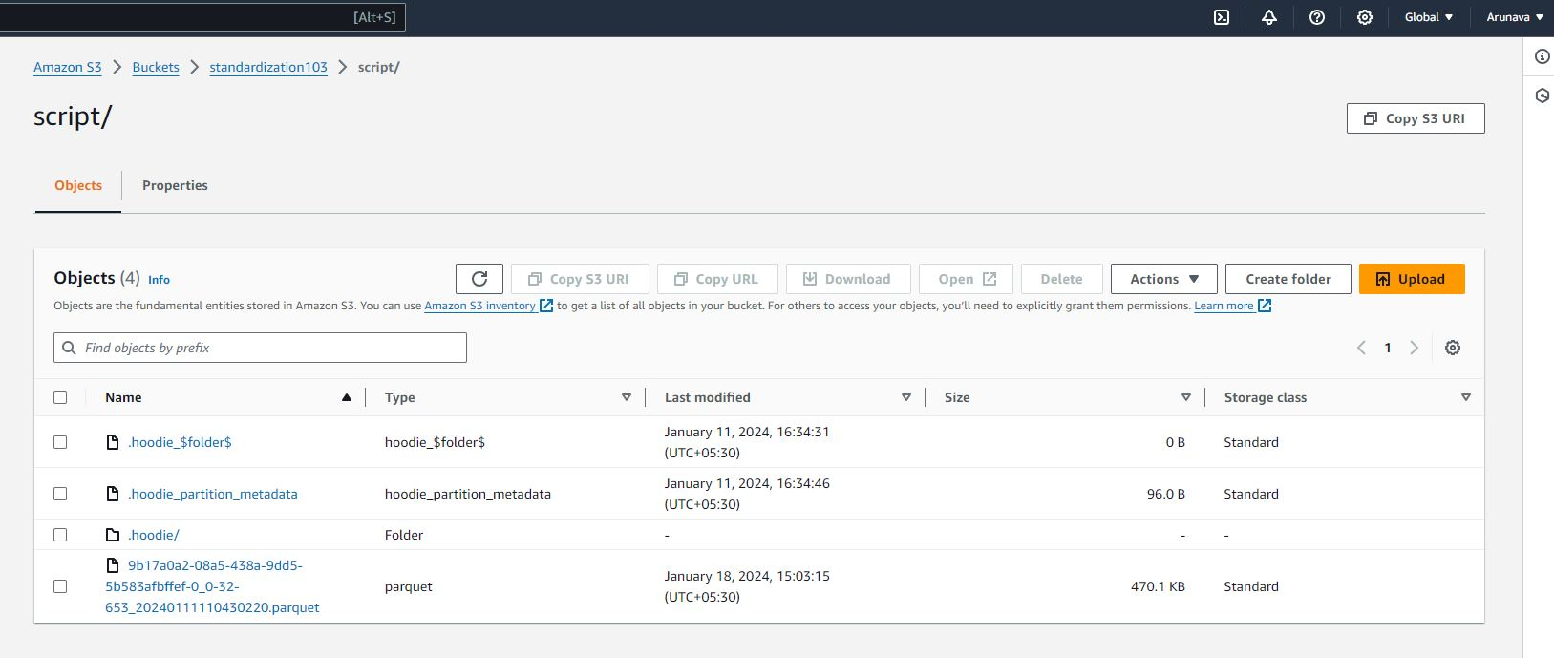

**CURATED:** This is the final zone, after filtering and putting the business logic (Redshift) in place we get the below file in the curated bucket.

